**Please open this file only in Microsoft Word to see/refer screen print for more details**

**Step to run NodeJS-Cucumber framework for UI and HTML report.**

D:\nodejs_project\QEAssignSolutions\FromScratch>D:/nodejs_project/QEAssignSolutions/FromScratch/node_modules/.bin/wdio

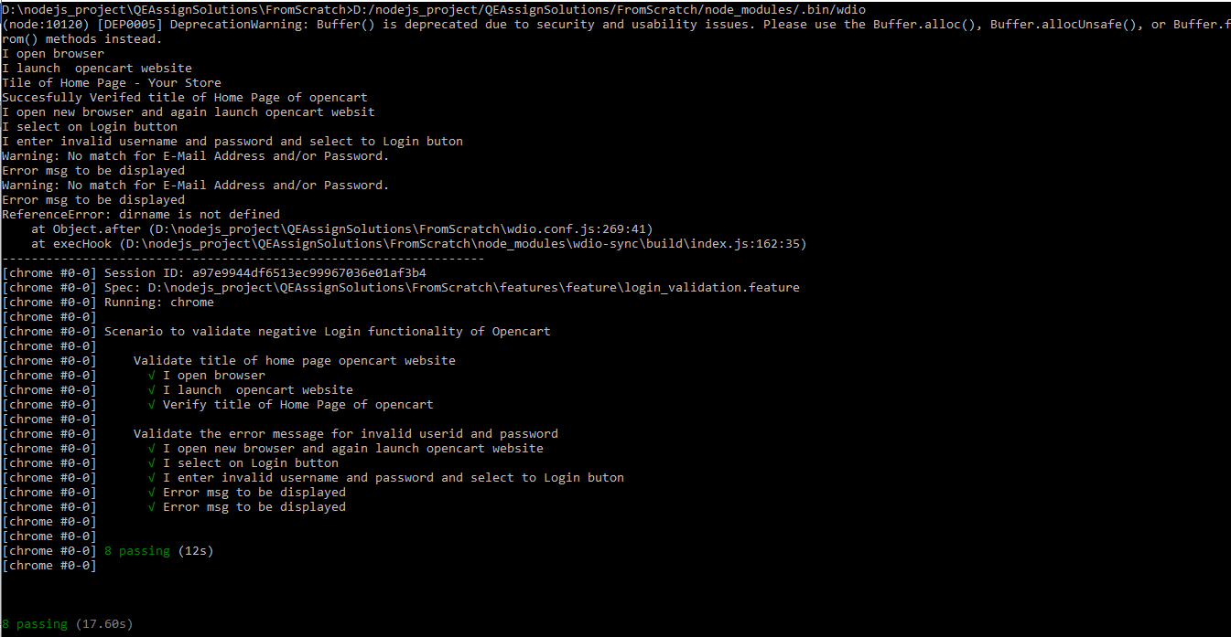

D:\nodejs_project\QEAssignSolutions\FromScratch>allure generate D:/nodejs_project/QEAssignSolutions/FromScratch/reports/allure-results –clean



D:\nodejs_project\QEAssignSolutions\FromScratch>allure open



Once “allure open” command run we get and display HTML report in browser.

